THE NEGATIVE MIND KRIYA FOR PROTECTION – Uit: Waves of Healing van Siri Atma Singh Khalsa
Throughout the kriya, concentrate at the Third Eye point with your eyes closed, and do long, deep breathing for 1-3 minutes, unless otherwise specified.
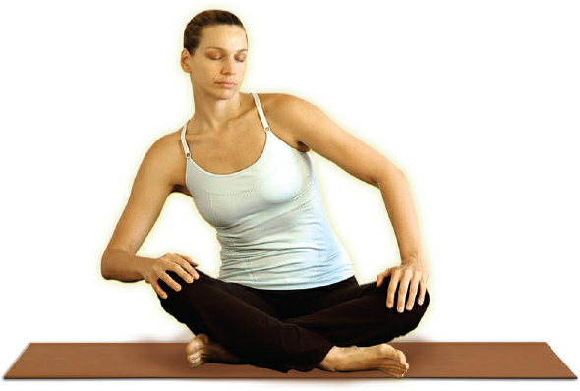
1.Sufi Grind. Sit in Easy Pose with your hands on your knees. Begin circling your torso from the base in one direction, keeping your spine straight. Feel the maximum stretch at the heart level. Inhale as you rotate forward, exhale as you rotate back. Change directions halfway though. To end, inhale, straighten the spine and apply Mulbandh; exhale and relax.
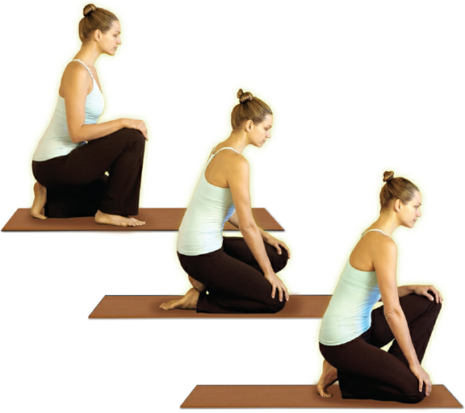
2.Walking Crow. Squat in Crow Pose with the feet flat on the floor and the hands on the knees. Keeping the knees bent and the right foot flat, raise the left heel and move the left knee forward. Then shift your weight, raise the right heel and move the right knee forward. With your eyes open, walk from one knee to the other, exhaling as each knee touches the floor, inhaling as you shift your weight.
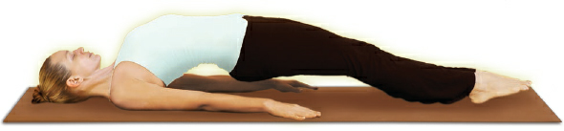
3.Lie on your back with your legs straight and your feet together. Pull the shoulders and shoulder blades together under your back and raise your buttocks. The arms remain straight on the floor. Keep the weight evenly distributed on the soles of your feet, your arms and shoulders, neck and head. Hold the posture as you do a powerful Breath of Fire.
4.Cobra Lotus Pose. Sit in Lotus Pose with your right foot on your left thigh, and your left foot on your right thigh. Place your hands by your sides and push up to bring your weight on your knees. Slowly lower yourself onto your stomach with your elbows bent and arch up into Cobra Pose, lifting your head last. Lift your chin without compromising your neck. Keep your shoulders relaxed and pulled slightly down.
If you cannot do the Cobra Lotus Pose, do the variation as pictured above. Start by lying on your stomach with your forehead on the floor. Place your hands under your shoulders pointing forward. Bend your knees, cross your ankles and raise your feet towards your buttocks. Raise the chest and arch slowly into Cobra Pose, lifting your head last. Lift your chin without compromising your neck. Keep your shoulders relaxed and pulled slightly down.
5.Sit in Easy Pose with your hands in Gyan Mudra. Keep your eyes wide open and rotate them in a clockwise direction, keeping your head fixed. Move your eyes precisely with the breath in the fashion described below; change direction to a counter-clockwise rotation half-way though.
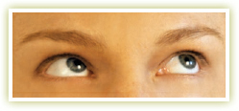
Inhale halfway with a short sniff and move your eyes to the upper left corner;
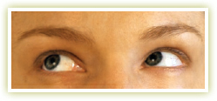
Inhale with a sniff to your maximum capacity, and move your eyes to the upper right corner;
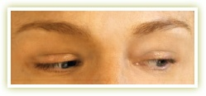
Exhale halfway with a sniff and move your eyes to the lower right corner;
Exhale with a sniff all the breath out and move your eyes to the lower left corner.
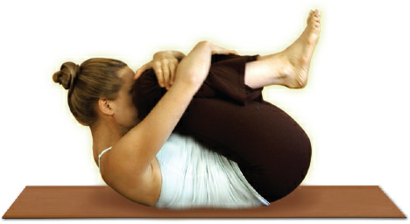
6.Lie on your back, pull your knees into your chest and wrap your arms around them. Lift your head and put your nose between your knees. Hold the position and do Breath of Fire.
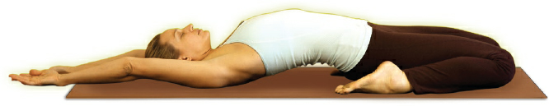
7.Celibate Pose Stretch. Sit with your buttocks on the floor between the heels. Put your hands behind your back and slowly move back until you are lying flat on the floor with your arms stretched overhead, palms facing up. If this is too difficult, support yourself on the hands or forearms with the spine, head and neck aligned.
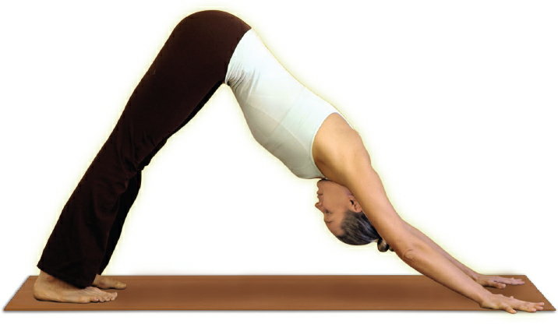
8.Triangle Pose. Come onto your hands and knees with your hands shoulder width apart under your shoulders, and the knees hip width apart. Your palms are flat on the floor, fingers spread apart, pointing forward. Roll your toes under so they grip the floor, and lift your buttocks up until your arms and legs are straight with palms and feet flat on the floor, forming a triangle. Press the base of the spine down while lifting the sitting bones upward. Keep the spine, head and neck aligned and apply a slight Jalandhar Bandh. Your eyes are directed toward your navel. Hold the position and inhale in 4 sniffs to maximum; exhale in 1 smooth stroke.
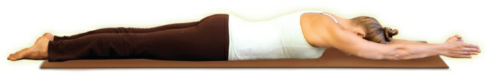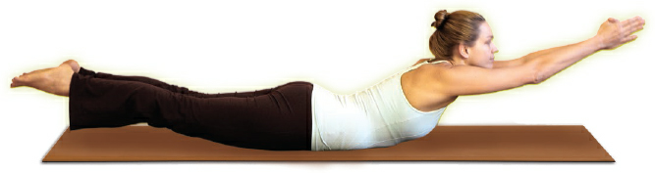
9.Come lying on your stomach with your legs straight, feet together and arms straight overhead, palms together.
Inhale and lift your arms, head, upper body and legs into Locust Pose; exhale and come down into the starting position. Continue the motion. To end, inhale and hold the posture briefly; exhale and relax.

